Name: Abdul Rehman

Roll no: 19L-1135

Section: Information Security (BCS-7H)

**Report:**

I used a NAT network on VirtualBox to do all the following:

Firstly, I identified the target machine IP address by running the netdiscover command.

It was 10.0.2.4

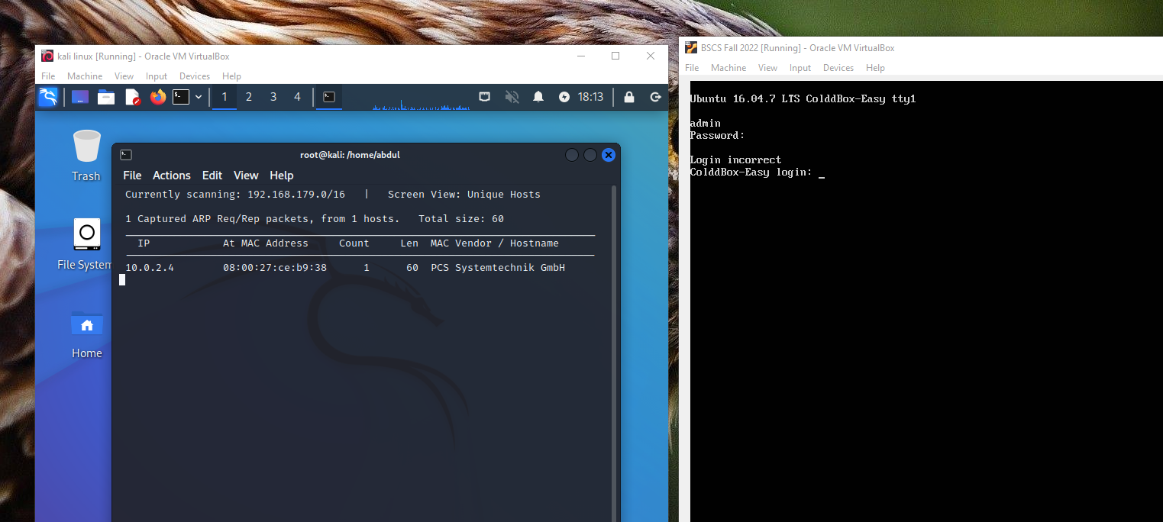

After getting the target machine IP address, I used the Nmap command to find the open ports and services on the machine as seen.

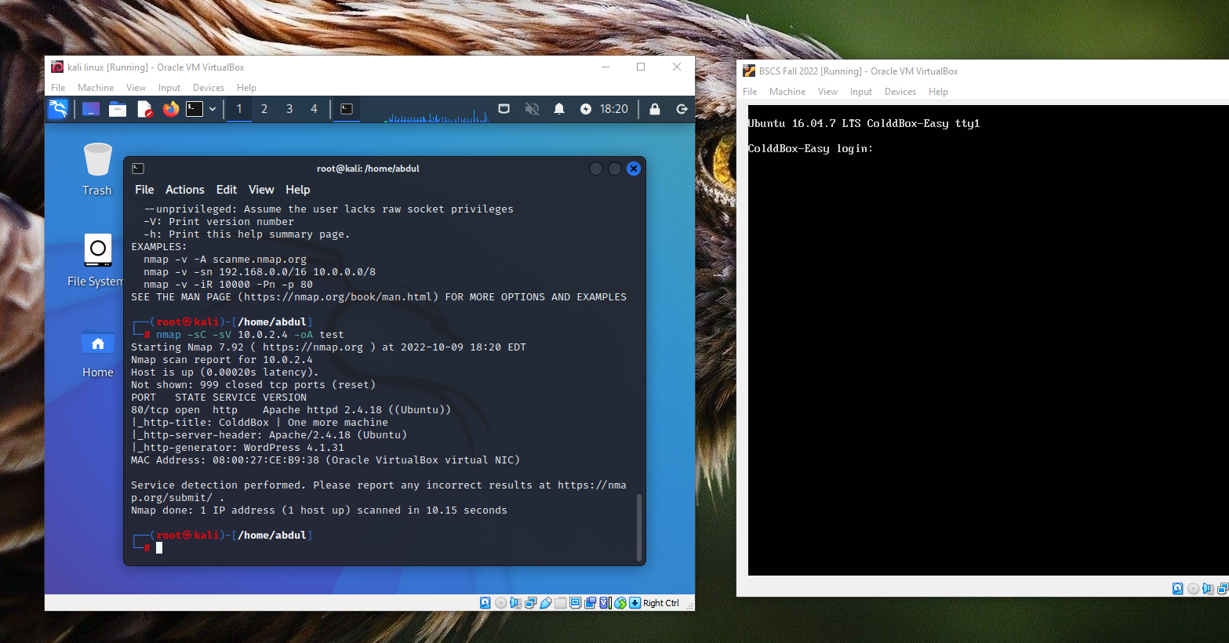

I then opened the target machine IP address on the browser to see the running web application. The admin page was accessible, so I ran a WordPress vulnerability scanner on this website using command wpscan.

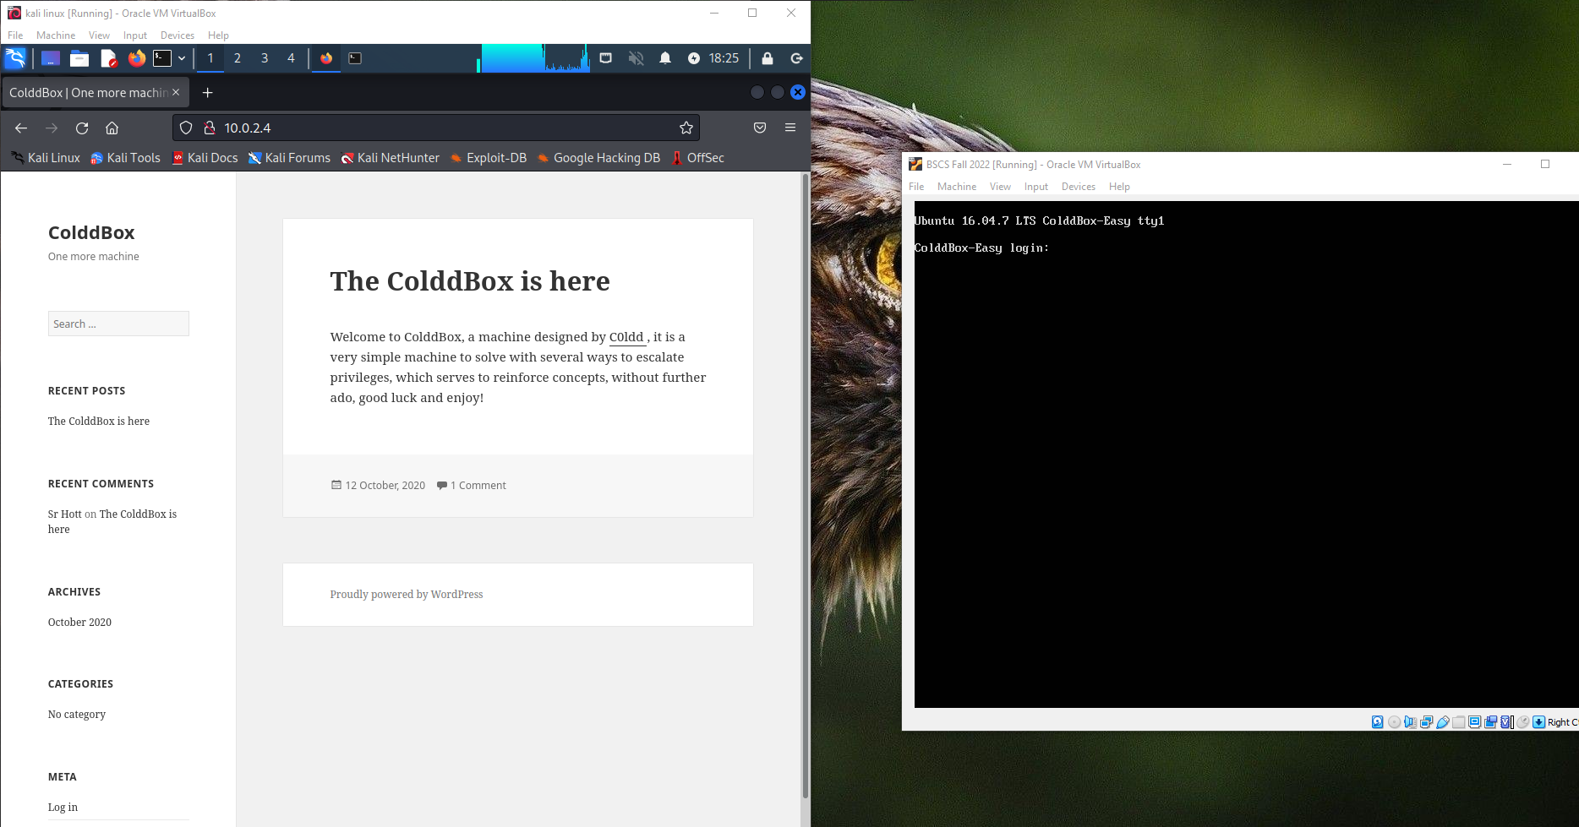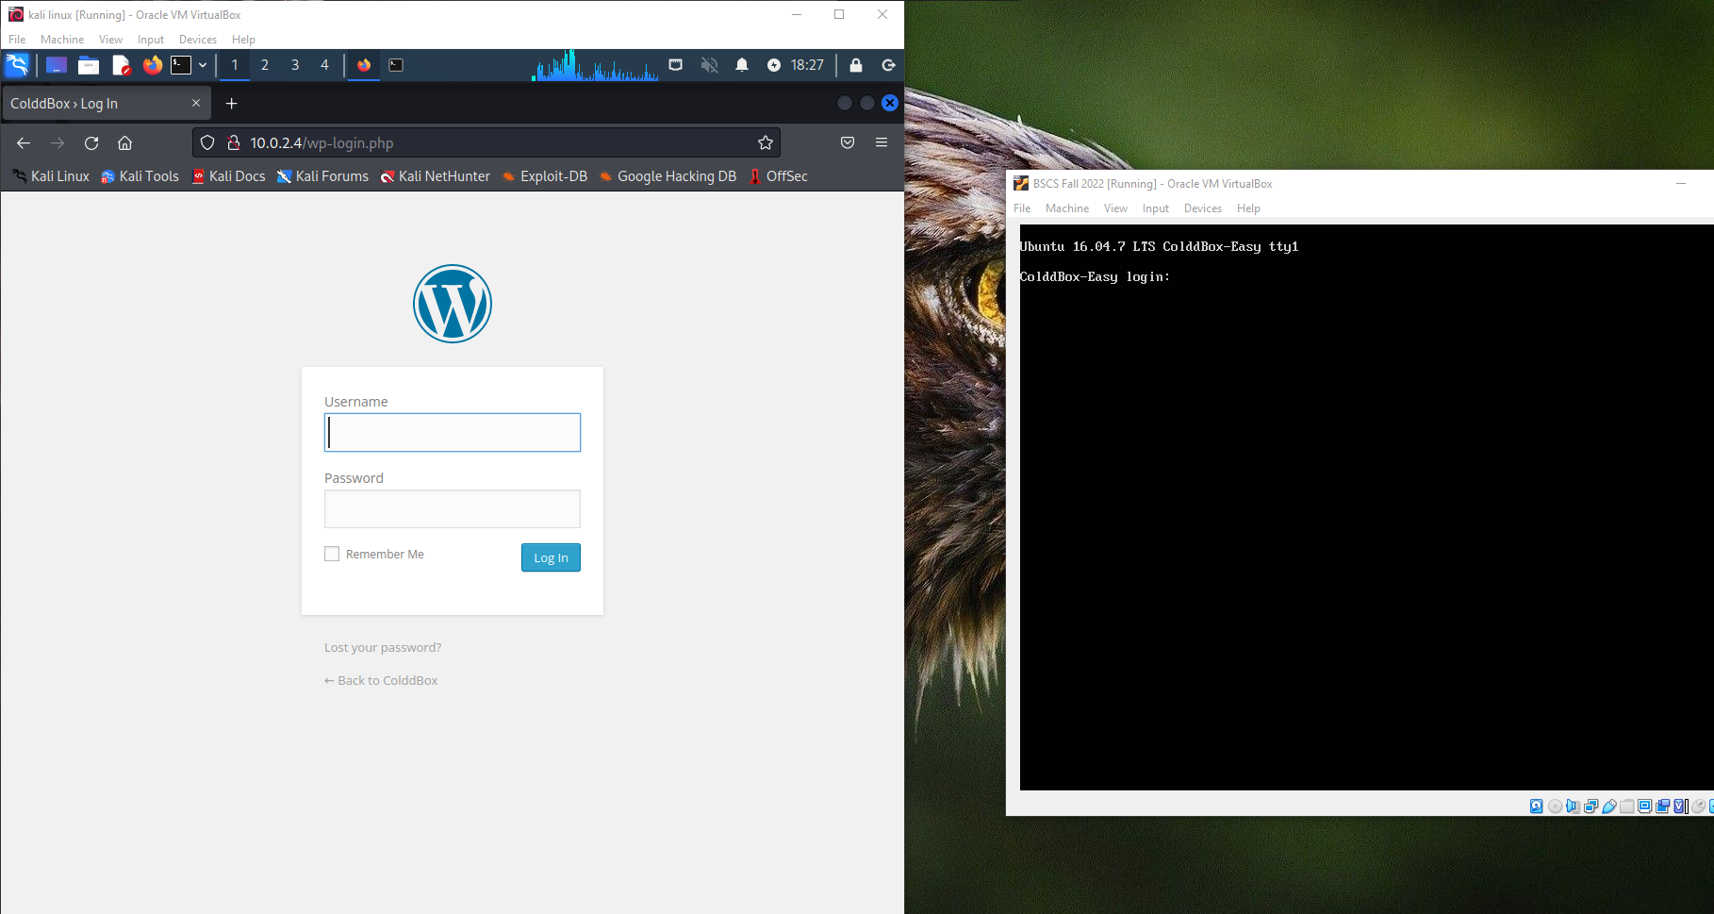

Then I enumerated the username by using the command:   
wpscan --url 10.0.2.4 -e u vp

However, I was unable to find any user.

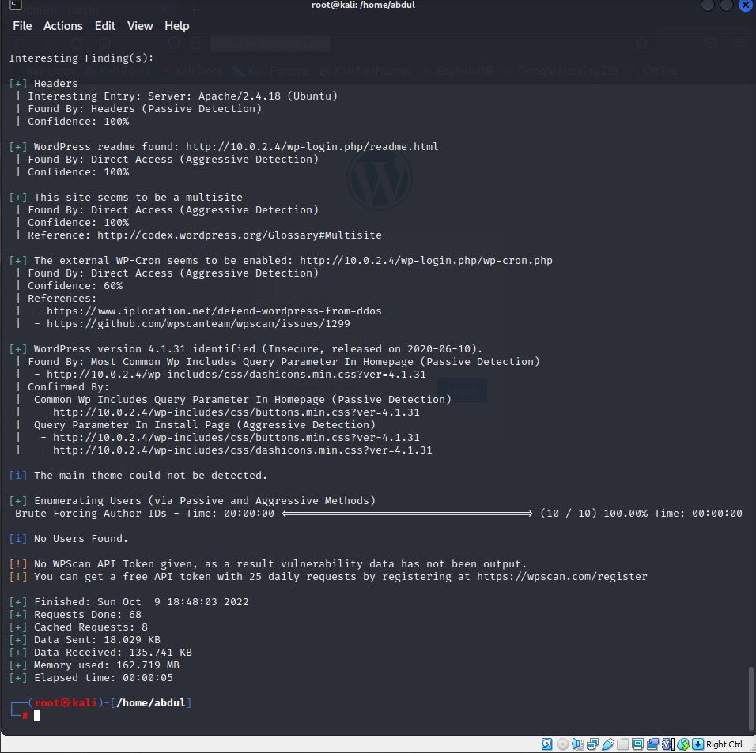

So, I applied brute force method, creating a file of top 10,000 common passwords and common username list for wordpress by using the command:

wpscan --url 10.0.2.4 -e -U ‘admin’, ‘administrator’, ‘test’, ‘testuser’ -P /home/abdul/Desktop/wordlist.txt

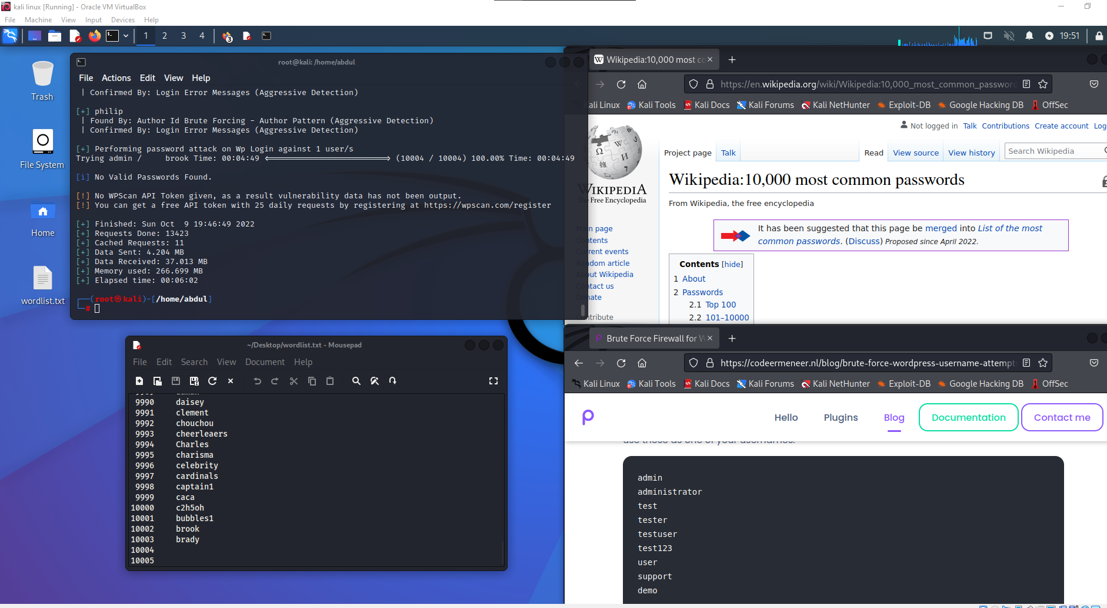

But even after applying the attack, it was not found.

In conclusion, I have profoundly understood the working and methods of attack and the mechanism for conducting such attacks. Unfortunately, due to some unknown issues with my hardware or virtual box, I was unable to find the login and password.